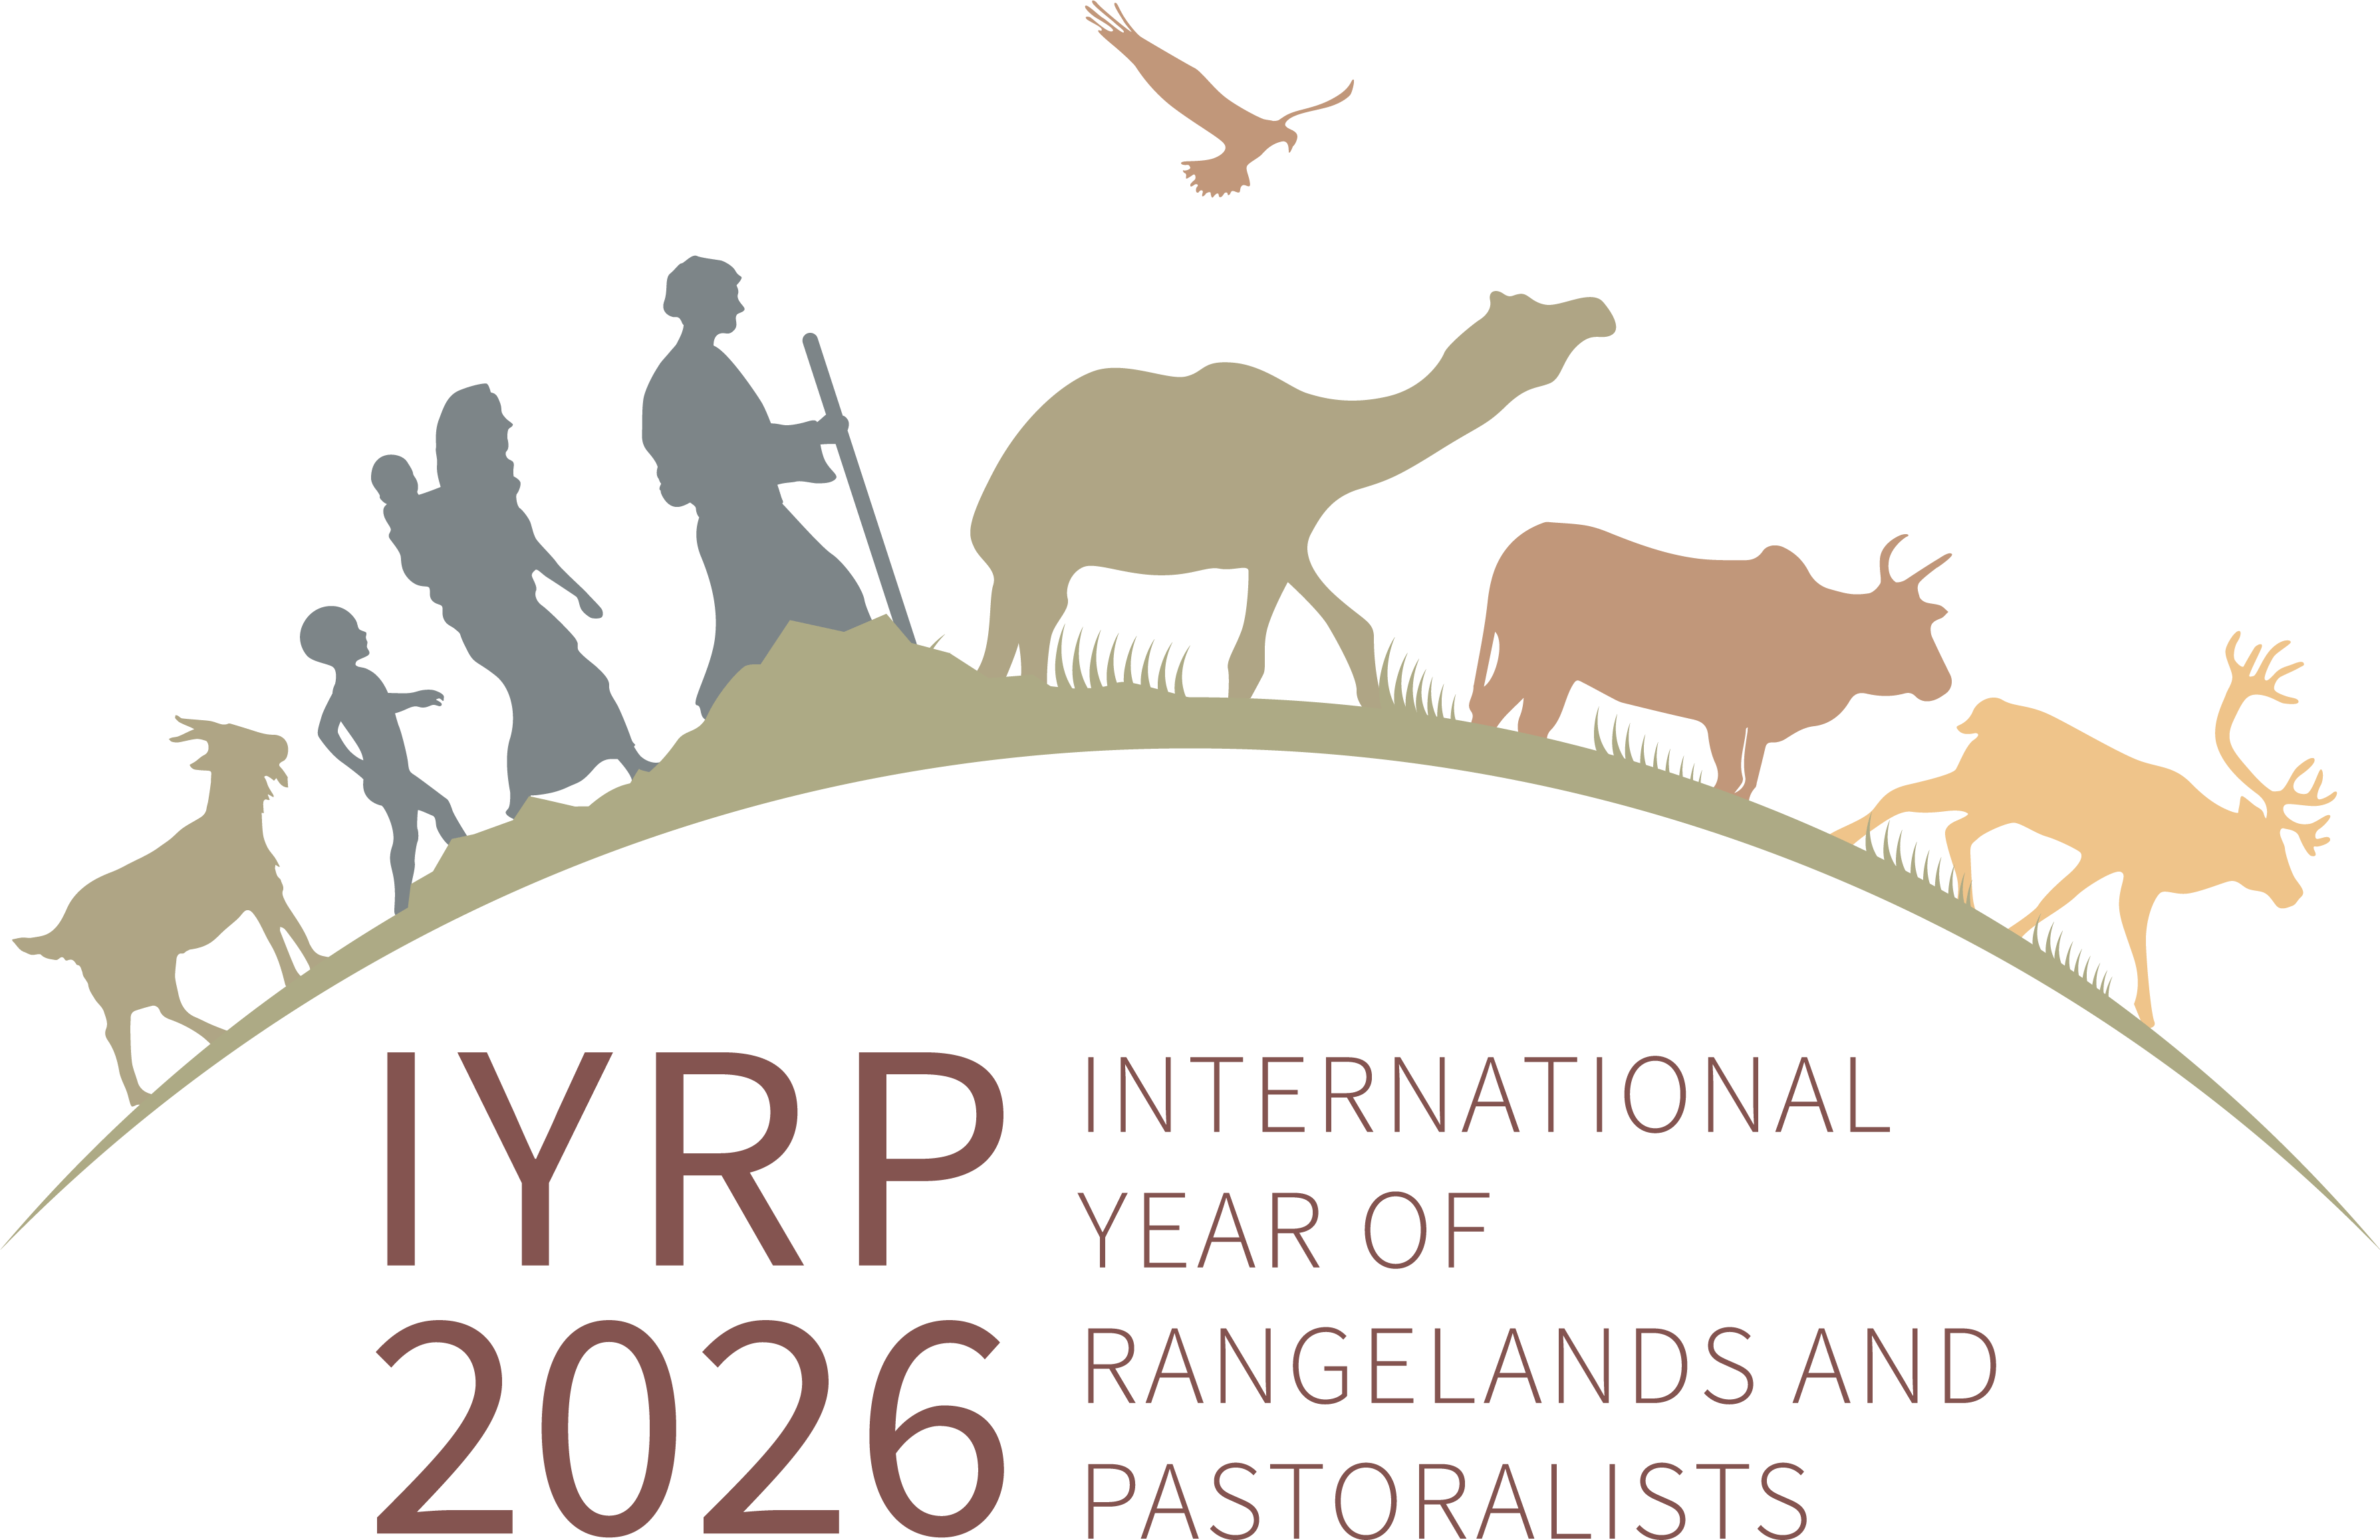
International Year of Rangelands & Pastoralists (IYRP):
information for pastoralist organisations

In March 2022, the United Nations (UN) declared 2026 as the International Year of Rangelands and Pastoralists (IYRP). This was proposed to the UN by the Government of Mongolia – traditionally a country of pastoralists – and was supported by 100 countries and 300 organisations worldwide. The UN has asked its Food and Agriculture Organization (FAO) to implement the IYRP to promote rangelands and pastoralists through awareness-raising and other activities. The alliance of people and organisations that supported Mongolia’s campaign for the IYRP – the International Support Group – is preparing for 2026 by creating opportunities for pastoralists and their organisations to be heard worldwide and to build recognition and support for pastoralism as the best way to use the world’s rangelands in a nature-positive way.
Why was an IYRP proposed?
Over half of the Earth’s land surface consists of rangelands: areas where the vegetation is made up of natural grasses and shrubs that are grazed by livestock and wildlife. The productivity and environmental health of rangelands are critical for the livelihoods and cultures of more than 500 million pastoralists. Billions more non-pastoralists benefit from these areas through animal products, tourism, wildlife and biodiversity conservation, renewable energy and other services.
The Government of Mongolia proposed an International Year so that more people – especially policymakers – would recognise the great value of rangelands and pastoralists and understand how they contribute to the economy, environment, society and culture at national and global level. The IYRP was proposed to raise awareness of the challenges and opportunities of life in the rangelands, including access to mobile health and education services, access to production inputs and markets, security of resource-use rights, conflict resolution and investment in maintaining or improving the rangelands. The IYRP would call attention to the need for better policies that favour pastoral production systems.

To make things clear

“Pastoralists” are people who raise livestock as their primary source of living on plants that grow naturally, often on areas called rangelands and grasslands.

A “pastoralist organisation” is a group of pastoralists who act together to improve the lives of the members, for example, by facilitating their access to information and markets and by advocating for pastoralists’ rights. The organisation may be registered (formal) or not (informal).

A “pastoralist support organisation” is a nongovernmental or governmental group of people who support pastoralists in their development and advocacy, but most of them do not practise pastoralism themselves.
Why is an IYRP important for pastoralists?
- To increase respect for the achievements of pastoralist men and women around the world in producing food and other products in challenging environments such as dry, mountainous and remote areas
- To strengthen pastoralist organisations and networks and make them more visible by providing a global platform to advocate for their rights and to exchange knowledge and good practices
- To showcase pastoralists’ pride in their work and culture, also among young people, and reinforce their traditions and diversity
- To enhance opportunities for pastoralists, including women and youth, to generate additional income through new products and markets by increasing understanding and appreciation of what they do
- To promote joint research by pastoralists and scientists to encourage innovation and adaptation and generate data about the situation of pastoralists and rangelands, so as to support pastoralists to manage land and water and lobby for their rights
- To influence policy and planning to integrate pastoralists’ concerns about their use of rangelands and other resources, securing livestock routes, protecting mobility, and peaceful negotiation of grazing and water access
- To reinforce efforts to set up services for appropriate animal and human healthcare and education for mobile pastoralist families.
Who is involved in the IYRP?
- The National Support Group established by the Government of Mongolia with members from civil society organisations and the Ministries for Agriculture, Environment & Tourism, and Foreign Affairs to coordinate the preparation for and implementation of the IYRP in Mongolia
- The International Support Group (ISG) with 500 members worldwide from international organisations, government agencies, universities, research institutes, nature-conservation groups and civil society organisations; one third of the ISG are from pastoralist and pastoralist-support organisations, including the World Alliance of Mobile Indigenous Peoples and Pastoralists (WAMIP)
- The Global Coordination Group of 48 people from all global regions
- The FAO Pastoralist Knowledge Hub (PKH) helps pastoralists advocate for sustainable rangeland use and pastoralist-friendly policies and supports the IYRP through its communication channels and events.
How can more pastoralist organisations become involved?
Send a letter of support for the IYRP: organisations that express support become members of the ISG and are included on the website as Friends of IYRP (https://www.iyrp.info/friends-of-iyrp).
Access resources on the IYRP website (www.iyrp.info) for news about IYRP-related activities and to hear the voices of pastoralists worldwide, including short videos and photos. Further films, photos and logos of your organisations are welcome!
Join one of the eleven Regional IYRP Support Groups (RISGs), which are implementing activities in their region in the lead-up to and during the IYRP. Pastoralist and pastoralist-support organisations are particularly welcome to help shape the IYRP. RISGs meet virtually and occasionally meet at international events, such as the International Rangeland Conference (IRC) to be held in Australia in 2025.
Join one of the thematic Working Groups and collaborate on topics such as afforestation in rangelands, biodiversity, climate change, gender, land, pastoral economics, water and youth. For contacts, see the IYRP Working Group Update
Examples of activities foreseen up to and during 2026
- National-level events, including showcasing sustainable pastoral systems, awards and prizes, innovation fairs, video documentaries, a World Herder Day and educational materials
- Social media campaigns and video productions to raise awareness of producers, consumers and policymakers worldwide
- Pastoralist gatherings – including gatherings of women pastoralists – at national, regional and global level to share knowledge and develop joint plans to improve the lives of pastoralists
- Joint research by pastoralists and scientists to fill in gaps in documented knowledge and information about pastoralists and rangelands at national and regional level
- An international conference on pastoralists, rangelands and the Sustainable Development Goals (SDGs), bringing together environmental, social and economic aspects in an integrated vision.
For more information, please see:
https:///www.iyrp.info
or contact iyrp2026@gmail.com

